　　　　　　　　　　　　　　　　　　　　Code：ECAP34

　 Questionnaire

Country :

Your Name :

**Please submit your answer by 12:00 on 15th November 2024.**

We would like you to let us know your opinion.

What theme of advanced technology, etc. do you want to focus on for next ECAP?

|  |
| --- |
|  |

【Reference】The following information is an example of advanced new technologies towards carbon neutrality.

ECAP 31 in 2023

ECAP 34 in 2024

Tentative Items of ECAP 37 in 2025

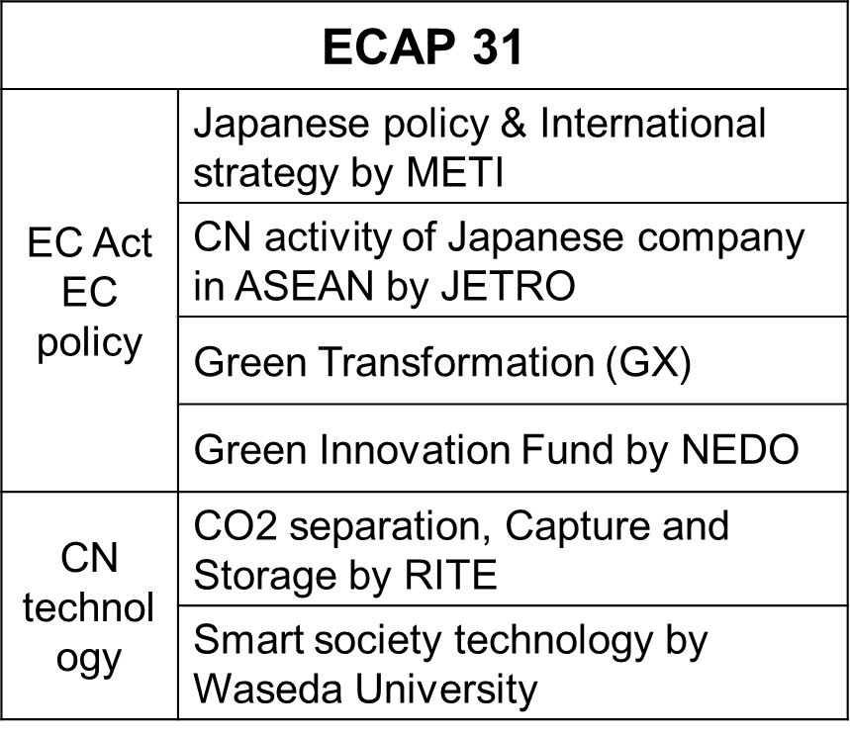

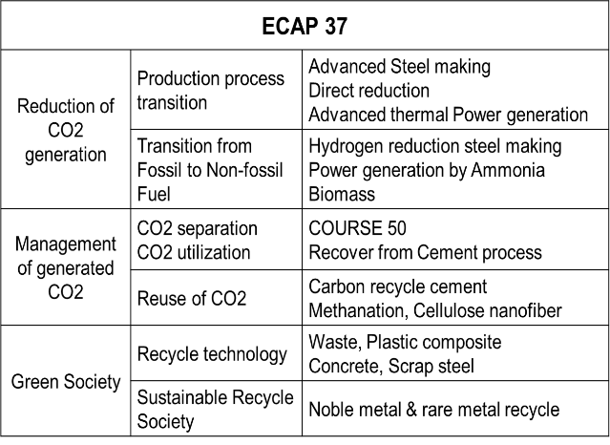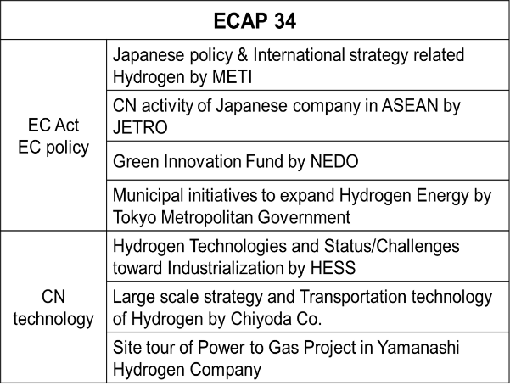

For future reference,　We would appreciate your informing us of any comments you may have.

|  |
| --- |
|  |

**Thank you very much for your kind cooperation and valuable feedback!**